Technology Stack, Architecture Execution plan and Operationalization

for

***Learning Assistance System***

**Contents**

1. OVERVIEW 2

2. Technology Stack 2

3. Architecture Execution plan 5

4. Operationalization (Support, Monitoring, Maintenance, etc) 6

# OVERVIEW

This document describes the technology choices made in context of the solution architecture developed for the Learning Assistance System. The following section provides details about the technologies selected for various layers as well as the reasoning for the selection. We have also provided a high-level plan for implementing the solution. This takes into consideration the dependencies, resource constraints and various other factors.

# Technology Stack

The technology stack comprises components or services that are used to implement an architecture solution. This includes description of the programming language, UI Frameworks, Operating system, system software, web components, database, hardware components, etc.

|  |  |  |
| --- | --- | --- |
| **Architecture Component** | **Technology Choice** | **Justification** |
| User Interface | HTML, CSS, JavaScript, AngularJS | HTML gives content structure and meaning by defining that content as, for example, headings, paragraphs, or images. CSS is a presentation language created to style the appearance of content—using, for example, fonts or colors.  AngularJS is the most preferred framework for creating interactive components of a website. AngularJS is very effective especially in creating dynamic, single page apps, and supports MVC structure. |
| Authentication | Amazon Cognito | Amazon Cognito is an Amazon Web Services (AWS) product that controls user authentication and access for mobile applications on internet-connected devices. Amazon Cognito associate’s data sets with identities and saves encrypted information as key or value pairs in the Amazon Cognito sync store. |
| Authorization | AWS Identity Services | AWS Identity Services enable you to quickly grant the right access, to the right people, at the right time by selecting permissions from a library of AWS managed policies, which you can also copy and create your own custom managed policy. |
| Security System | AWS Key Management Service (KMS) | AWS Key Management Service (KMS) makes it easy for you to create and manage cryptographic keys and control their use across a wide range of AWS services and in your applications. AWS KMS is a secure and resilient service that uses hardware security modules |
| Programming/Scripting languages | Front end – HTML, CSS, JavaScript  Backend – JavaScript, Java | Most used programming/scripting languages |
| Communication Platform | Amazon Chime | Amazon Chime is a communications service that lets you meet, chat, and place business calls inside and outside your organization, all using a single application. Developers can use the same communications infrastructure and services that power Amazon Chime, and add audio calling, video calling, and screen sharing capabilities directly to their applications using the Amazon Chime SDK. |
| Mobile Operating System | Android, iOS | These are the most used mobile operating system |
| Email Notification System | SendGrid | SendGrid is a cloud-based SMTP provider that allows you to send email without having to maintain email servers. We can send 40,000 emails for 30 days, then 100/day forever |
| Database | Amazon Relational Database Service (Amazon RDS) | Amazon Relational Database Service (Amazon RDS) makes it easy to set up, operate, and scale a relational database in the cloud. It provides cost-efficient and resizable capacity while automating time-consuming administration tasks such as hardware provisioning, database setup, patching and backups. |
| Support System | SendGrid, Amazon Directory Service | SendGrid is a cloud-based SMTP provider that allows you to send email without having to maintain email servers. We can send 40,000 emails for 30 days, then 100/day forever.  The AWS Directory Service is an Amazon Web Services tool that allows enables an IT administrator to run Microsoft Active Directory (AD) in the public cloud, easing setup of user and group data and giving an end user access to AWS cloud services. |
| Web service & App service | Amazon Web Service(AWS) | AWS is preferred because:  Amazon Web Services make for a durable and secure technology platform. To ensure the safety and integrity of your data, Amazon's data centers and services have several layers of physical and operational security. AWS also conducts regular audits to ensure its infrastructural security  Their business model is designed to run at cost+ pricing, with a fixed margin such that as they reduce their costs, their pricing also reduces  Focus on simplicity, security, robustness, and scalability over arbitrary feature creep |
| Browsers supported | Google Chrome, Safari, Internet Explorer | These are the most used and user-friendly search engines |
| Scalability | Auto enabled will be activated based on the load and user requests by AWS infrastructure | Save one-year cost by using AWS free tier and then enroll after 1st year |

# Architecture Execution plan

3.1 **TIMELINE**

Following is how all the business requirements can be divided in various phases and then implemented iteratively

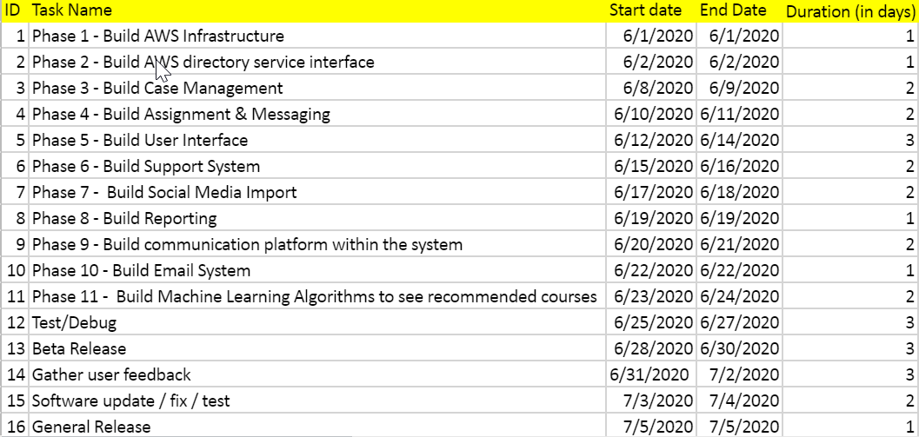



# Operationalization (Support, Monitoring, Maintenance, etc)

|  |  |
| --- | --- |
| **Operationalization** | **Description** |
| **Support** | Provide support by creating multiple instances to have backup. If primary goes down, back-up will take care of providing the support to users until primary comes up. |
| **Monitoring** | Automated monitoring tools to watch Amazon EC2 and report back when something is wrong:  1. System Status Checks - monitor the AWS systems required to use instance to ensure they are working properly.  Examples of problems that cause system status checks to fail include: Loss of network connectivity Loss of system power Software issues on the physical host Hardware issues on the physical host that impact network reachability  2. Instance Status Checks - monitor the software and network configuration of individual instance. |
| **Maintenance** | When a bug occurs on the user end and if the user clicks on HELP and log a ticket, continuous support is provided by admin who will navigate it to operations team (or a particular team). The team then will prioritize the task by creating a user story and will re-deploy the code. Otherwise, that particular bug can be solved only for that user and will be ignored without prioritizing the tasks |